**Database for an Educational Institution**

[Mahima Chowdary Kodali](mailto:mahimachowdarykoda@lewisu.edu)

**Student ID -** 30065273

**Email-** mahimachowdarykoda@lewisu.edu

In this section, it would be going to implement the indexes in two different table where in general index could be deployed to retrieve the data from the database quickly but there would not be any differences in the speed of retrieval though the database created are small. After the implementation of indexes in the database table, it has to be implemented views in the database table where it could depict the virtual table based on the requirements. The implementation steps of both the indexes and views are to be portrayed in the below section.

# Implementation of Indexes in Table

## Index 1

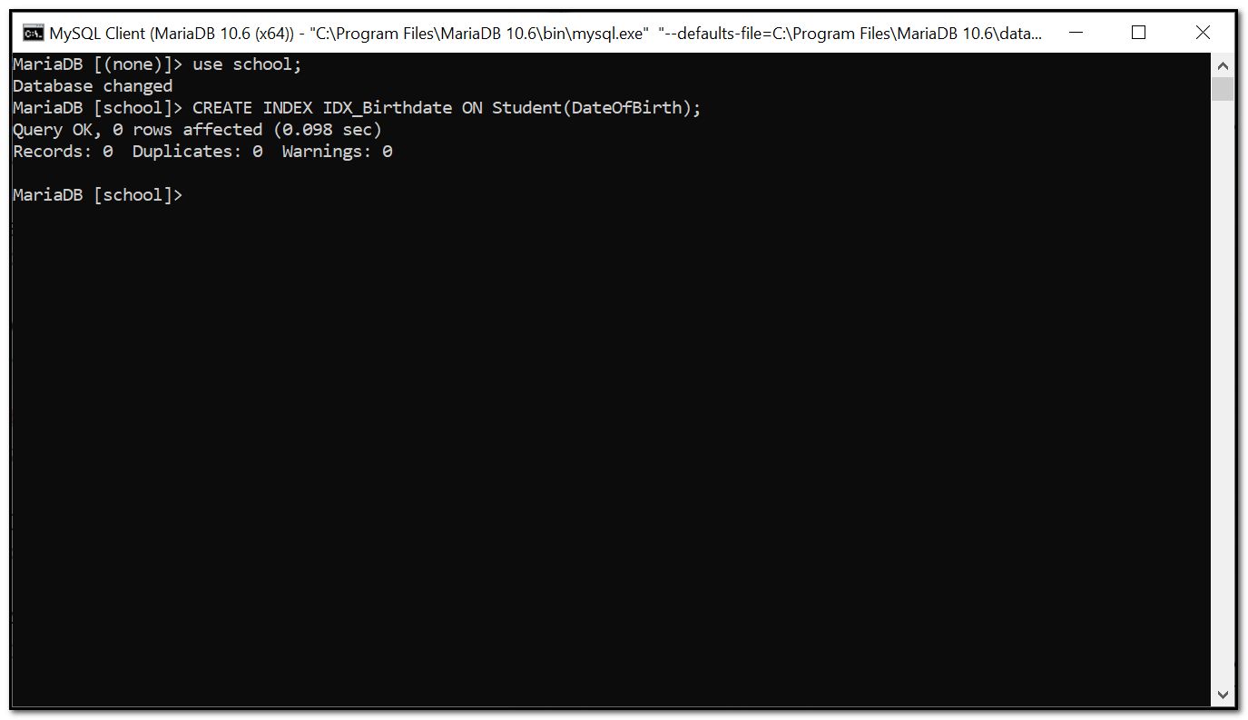

In this, from the school database, it had been indexed the date of birth of the student where it would be act as the unique identifier for the respective student.

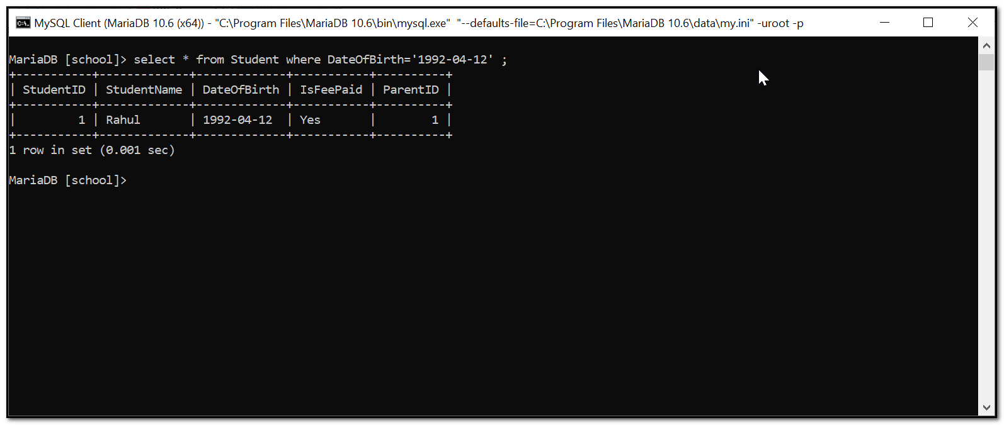

When the SQL query “select *from Student where DateOfBirth='1992-04-12';” provided for viewing the student details with the specified date of birth, then it could retrieve the respective data fast and shows the result in the form of table.

## Index 2

CREATE INDEX IDX_SubjectName ON Subject(SubjectName);

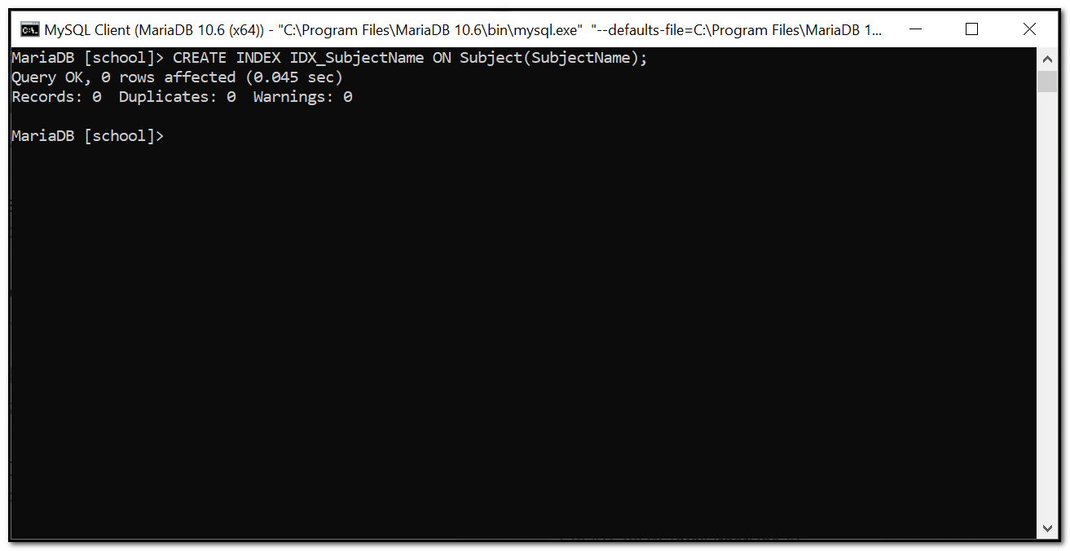

Now, it had been implemented the index on the Subject table where the query had been provided to view the subject name quickly from the database table.

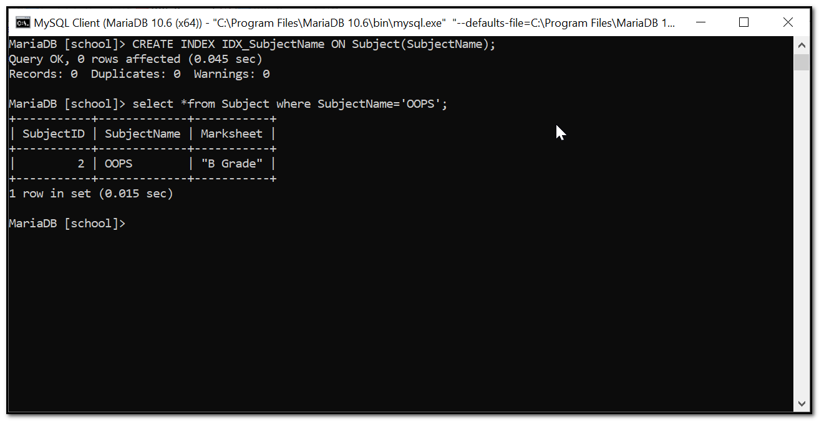

By providing the query “select *from Subject where SubjectName='OOPS';” , it could view the details of the subject details with ID and grade from the subject table.

I added an index to my School Fees Details table because the table could contain the significant information about the fee’s details of the students like whether they paid or not and so on. And the index created to view the school fees details of the respective student could improve the performance where it can be quickly identified whether the specified student paid the school fees or not. Likewise, in the Subject table, the index is added to view the information about the specified subject and this would improve the performance of the lecturer to proceed with the subject for the classes.

# Implementation of Views in table

## View 1

Create view StudentFeesDetails

as

SELECT S.StudentName,S.IsFeePaid,AVG(T.FeesDetails)

FROM Student S JOIN Transportation T

ON S.StudentID=T.StudentID

GROUP BY S.StudentName,S.IsFeePaid;

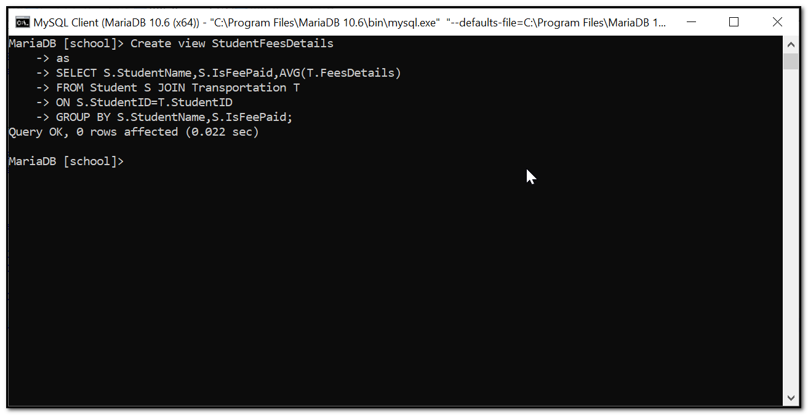

The view could be useful for depicting the virtual table where the SQL query was provided to depict the student fees details where the table must contains the student name, is fees paid, average, transportation of the specified student.

Select * from StudentFeesDetails;

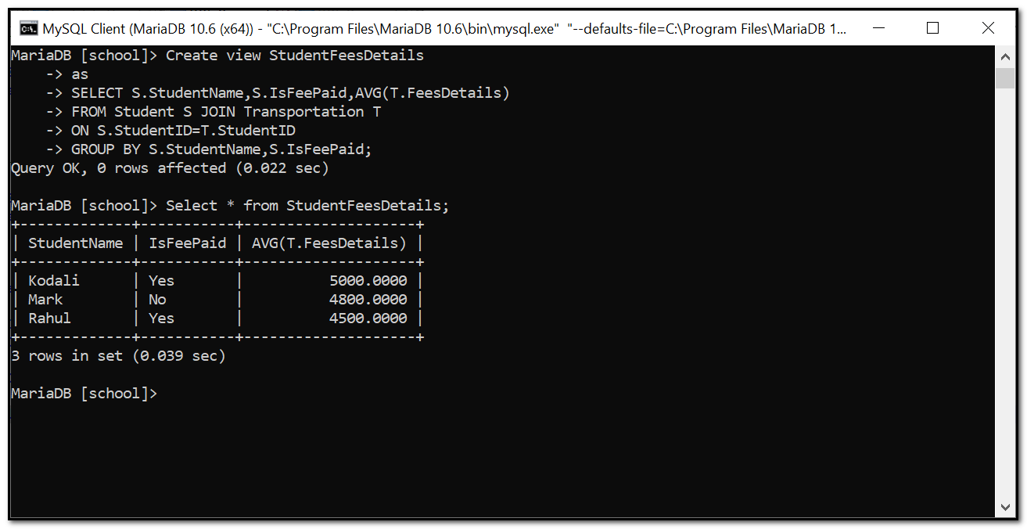

The SQL query “Select * from StudentFeesDetails;” could be given to depict the details from the Student Fees Details.

## View 2

Create view StudentDetails

as

SELECT S.StudentName,SUB.SubjectName,T.FeesDetails

FROM Student S JOIN Transportation T JOIN Subject SUB JOIN StudentSubject SS

ON S.StudentID=T.StudentID AND S.StudentID=SS.StudentID AND SUB.SubjectID=SS.SubjectID

GROUP BY S.StudentName,SUB.SubjectName;

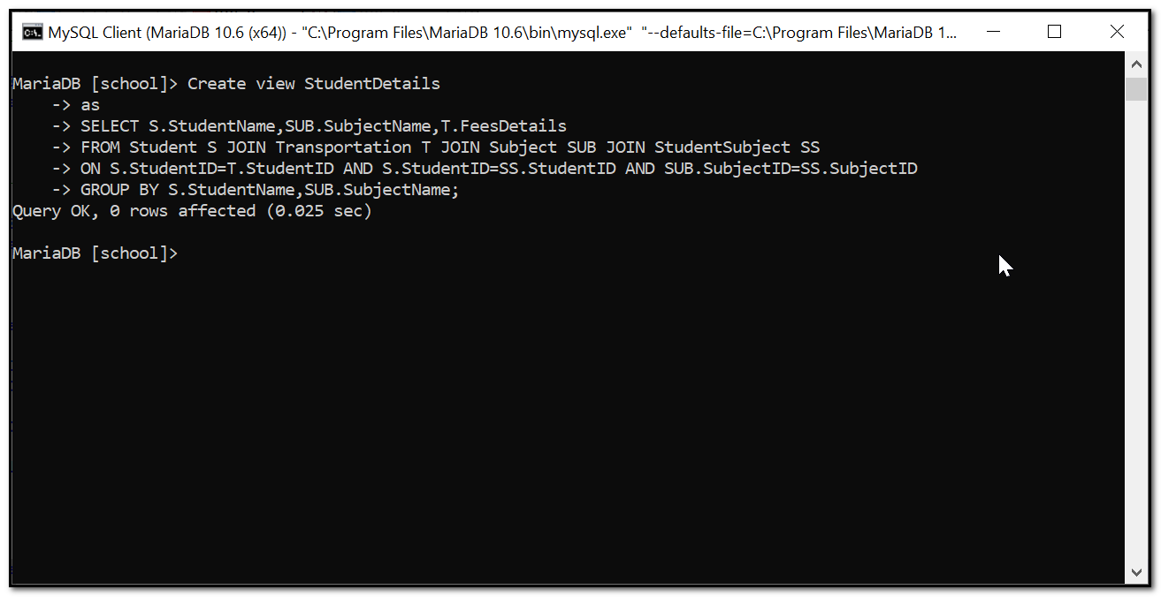

The view could be implemented in the Student details table where to depict the fees details along with the transportation and subject name with several student details.

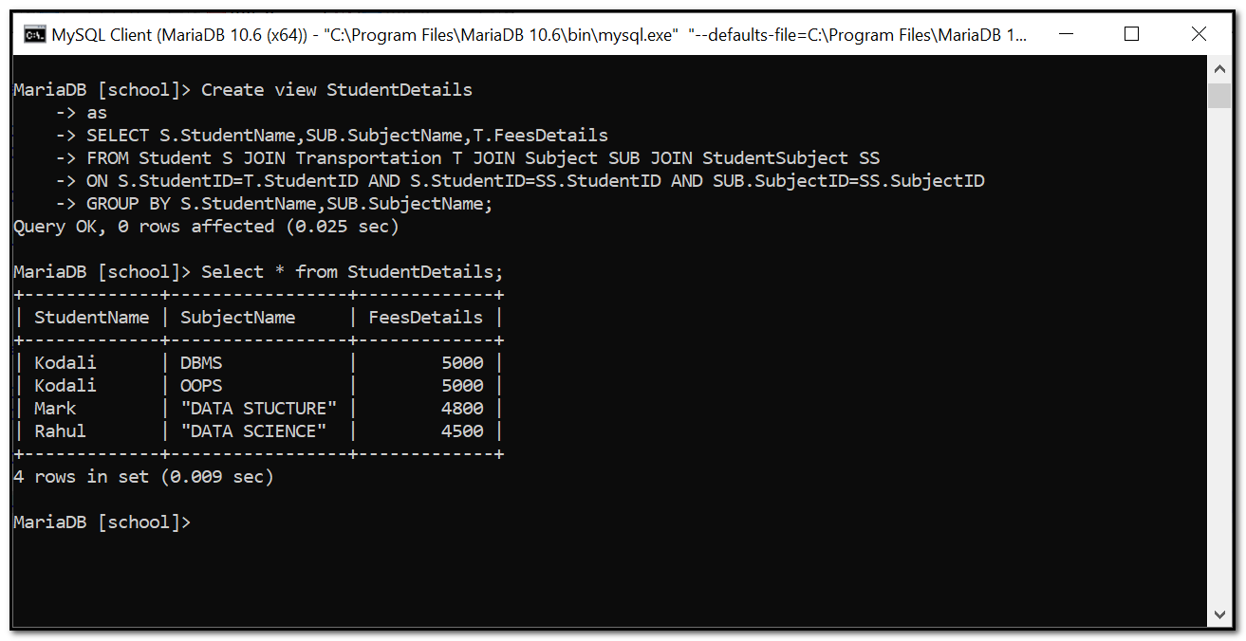

Now, it had been entered the query as “Select * from StudentDetails;” to view the virtual table that contains the information about the student name, subject name and fees details. It is valuable to the database where it contains the subject and fees details for the students.

At first, it had been depicted the virtual table for Student fees details with fees paid or not with specified ID where it could be useful for the administrator to identify the details of the student who paid or not paid the fees. Then, it had been viewed the Student Details with the student name, subject and respective fees details and this could be useful for the students to identify their fees for the particular subject.